Data Collection and Preprocessing Phase

Name | Nilofar Rafik Shaikh
Skillwallet ID | SWUID20260283092
Project Title | Uncovering the Hidden Treasures of the  Mushroom Kingdom A Classification Analysis
Maximum Marks | 6 Marks

Data Preprocessing
The images will be preprocessed by resizing, normalizing, augmenting, denoising, adjusting contrast, detecting edges, converting color space, cropping, batch normalizing, and whitening data. These steps will enhance data quality, promote model generalization, and improve convergence during neural network training, ensuring robust and efficient performance across various computer vision tasks.
Section | Description
Data Overview | This project uses image datasets of three mushroom species: Boletus, Lactarius, and Russula. The images are collected from various sources including SmartInternz, custom fieldcaptured images, and platforms like Kaggle and Wikimedia. This ensures rich visual diversity and robust generalization during training.
Resizing | All images are resized to 224×224 pixels using OpenCV’s cv2.resize() function to ensure uniform input dimensions for CNN-based models.
Normalization | Pixel values are normalized to the range [0, 1] by dividing by 255.0, improving convergence during model training.
Data Augmentation | Using ImageDataGenerator, images are augmented with random rotation, shifts, zoom, horizontal/vertical flips, and fill modes to avoid overfitting.
Denoising | OpenCV’s fastNlMeansDenoisingColored() is applied to reduce environmental noise and improve image clarity, especially for field-captured data.

Edge Detection | cv2.Canny() is used for edge detection, helping to emphasize structure, texture, and contour features of different mushroom species.
Color Space Conversion | Images are converted from BGR to HSV color space using cv2.cvtColor() to better capture color-based patterns across lighting variations.
Image Cropping | Manual center cropping is done on some images to focus on the mushroom body and reduce irrelevant background noise, enhancing object recognition.
Batch Normalization | BatchNormalization() is applied in the neural network model to stabilize and accelerate the learning process by reducing internal covariate shift.
Data Preprocessing Code Screenshots
Loading Data | 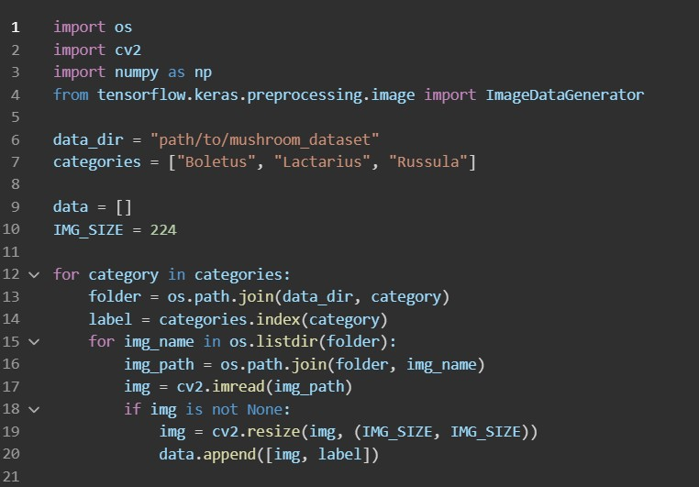
Resizing
Normalization | 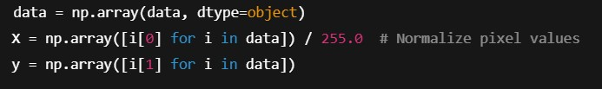
Data Augmentation | 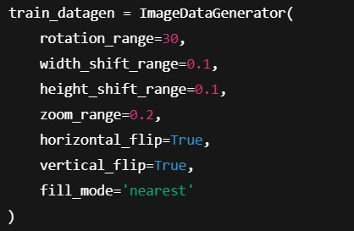
Denoising
Edge Detection
Color Space Conversion
Image Cropping
Batch Normalization | 